Pre configuration on local workstation to connect to Nacha ask cluster  
  
1. Go to Powershell and verify if az cli in installed.  
  
 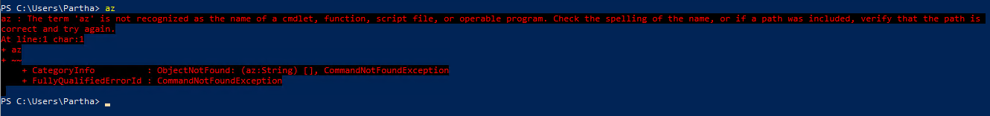  
  
 if you see above error that’s indicates az is not installed, install azure cli  
  
 visite page “[Azure CLI installation page](https://www.google.com/search?q=Azure+CLI+installation+page&rlz=1C1RXQR_enUS1110US1110&oq=Azure+CLI+installation+page&gs_lcrp=EgZjaHJvbWUyBggAEEUYOTIHCAEQABiABDIKCAIQABiiBBiJBTIKCAMQABiABBiiBDIKCAQQABiABBiiBDIKCAUQABiABBiiBDIKCAYQABiABBiiBNIBCDEzNTBqMGo3qAIIsAIB&sourceid=chrome&ie=UTF-8)”  
  
 Go ahed and install azure cli 64 bit for windows  
   
 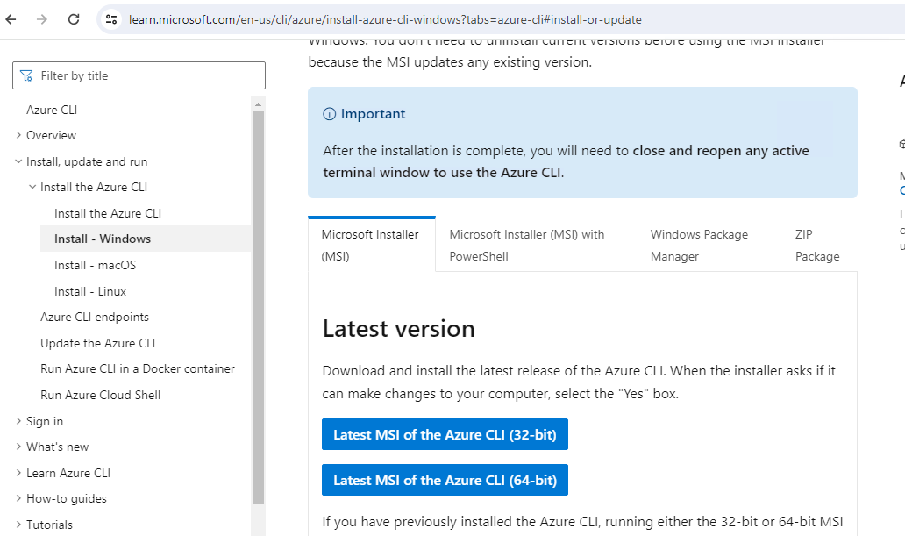  
  
 Restart the powershell, make sure az installed successfully.  
  
 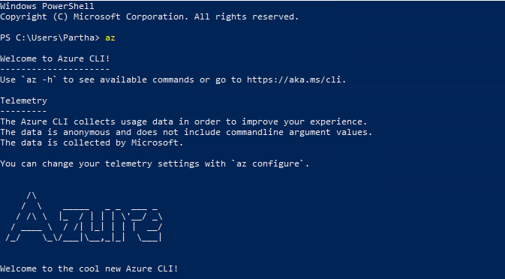

$url = "c"

$zipFilePath = "$env:TEMP\kubelogin.zip"

$extractPath = "$env:TEMP\kubelogin"

$destinationPath = "C:\Program Files\kubelogin"

# Download the ZIP file

Invoke-WebRequest -Uri $url -OutFile $zipFilePath

# Extract the ZIP file

Expand-Archive -Path $zipFilePath -DestinationPath $extractPath -Force

# Verify the extracted path for kubelogin.exe

$extractedFilePath = "$extractPath\kubelogin.exe"

if (-Not (Test-Path -Path $extractedFilePath)) {

$extractedFilePath = Get-ChildItem -Path $extractPath -Recurse -Filter kubelogin.exe | Select-Object -First 1 -ExpandProperty FullName

}

# Create the destination directory if it doesn't exist

if (-Not (Test-Path -Path $destinationPath)) {

New-Item -ItemType Directory -Path $destinationPath

}

# Move the executable to the destination directory

Move-Item -Path $extractedFilePath -Destination $destinationPath -Force

# Add the destination directory to the system PATH if not already present

$path = [System.Environment]::GetEnvironmentVariable”("Path", [System.EnvironmentVariableTarget]::Machine)

if ($path -notlike "*$destinationPath*") {

[System.Environment]::SetEnvironmentVariable("Path", "$path;$destinationPath", [System.EnvironmentVariableTarget]::Machine)

}

# Clean up

Remove-Item -Path $zipFilePath -Force

Remove-Item -Path $extractPath -Recurse -Force

Write-Host "kubelogin installation completed. Please restart your PowerShell or Command Prompt."

2. Verify Kubelogin in installed on your server  
  
 type “kubelogin” on powershell  
  
 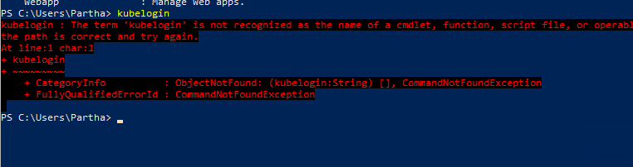  
  
 if you see above error, then go Ahed and install kubelogin.  
  
  
Copy below script from below textbox and run on powershell (run as administrator), wait for few minutes.

$url = "c"

$zipFilePath = "$env:TEMP\kubelogin.zip"

$extractPath = "$env:TEMP\kubelogin"

$destinationPath = "C:\Program Files\kubelogin"

# Download the ZIP file

Invoke-WebRequest -Uri $url -OutFile $zipFilePath

# Extract the ZIP file

Expand-Archive -Path $zipFilePath -DestinationPath $extractPath -Force

# Verify the extracted path for kubelogin.exe

$extractedFilePath = "$extractPath\kubelogin.exe"

if (-Not (Test-Path -Path $extractedFilePath)) {

$extractedFilePath = Get-ChildItem -Path $extractPath -Recurse -Filter kubelogin.exe | Select-Object -First 1 -ExpandProperty FullName

}

# Create the destination directory if it doesn't exist

if (-Not (Test-Path -Path $destinationPath)) {

New-Item -ItemType Directory -Path $destinationPath

}

# Move the executable to the destination directory

Move-Item -Path $extractedFilePath -Destination $destinationPath -Force

# Add the destination directory to the system PATH if not already present

$path = [System.Environment]::GetEnvironmentVariable”("Path", [System.EnvironmentVariableTarget]::Machine)

if ($path -notlike "*$destinationPath*") {

[System.Environment]::SetEnvironmentVariable("Path", "$path;$destinationPath", [System.EnvironmentVariableTarget]::Machine)

}

# Clean up

Remove-Item -Path $zipFilePath -Force

Remove-Item -Path $extractPath -Recurse -Force

Write-Host "kubelogin installation completed. Please restart your PowerShell or Command Prompt."

After successful completion of script you will see success message “kubelogin installation completed. Please restart your PowerShell or Command Prompt."  
  
  
  
 Or you can install manually [link](https://github.com/Azure/kubelogin/releases)  
  
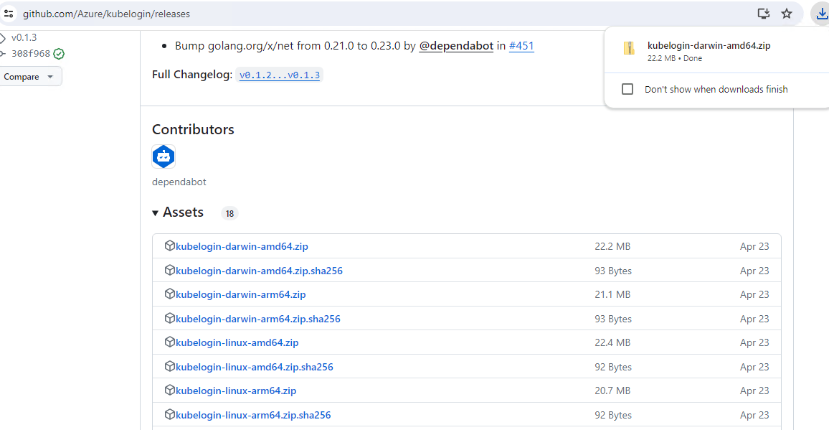

* You can place the kubelogin.exe file in a directory that is included in your system’s PATH, such as C:\Windows\System32.
* Alternatively, you can add the directory where you placed kubelogin.exe to your PATH environment variable.  
    
    
  Restart PowerShell and run “kubelogin –version”  
    
  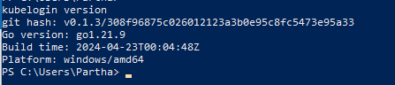

3. install kubectl

Run powershell as admin and run the script below

# Define the URL for the latest kubectl release

$url = "https://dl.k8s.io/release/v1.26.0/bin/windows/amd64/kubectl.exe" # Update with the latest stable version if needed

$destinationPath = "C:\Program Files\kubectl"

$executablePath = "$destinationPath\kubectl.exe"

# Create the destination directory if it doesn't exist

if (-Not (Test-Path -Path $destinationPath)) {

New-Item -ItemType Directory -Path $destinationPath

}

# Download kubectl.exe

Invoke-WebRequest -Uri $url -OutFile $executablePath

# Add the destination directory to the system PATH if not already present

$path = [System.Environment]::GetEnvironmentVariable("Path", [System.EnvironmentVariableTarget]::Machine)

if ($path -notlike "*$destinationPath*") {

[System.Environment]::SetEnvironmentVariable("Path", "$path;$destinationPath", [System.EnvironmentVariableTarget]::Machine)

}

Write-Host "kubectl installation completed. Please restart your PowerShell or Command Prompt."

# Verify kubectl

kubectl version --client

Or you can download and install manually. [Link](https://kubernetes.io/docs/tasks/tools/)

Verify Kubectl installed successfully.  
  
>> kubectl –version

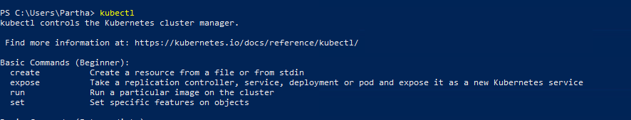

**Commands to install Kubectl**   
  
1. curl.exe -LO "[https://dl.k8s.io/release/v1.31.0/bin/windows/amd64/kubectl.exe"](https://dl.k8s.io/release/v1.31.0/bin/windows/amd64/kubectl.exe%22)2. curl.exe -LO "[https://dl.k8s.io/v1.31.0/bin/windows/amd64/kubectl.exe.sha256"](https://dl.k8s.io/v1.31.0/bin/windows/amd64/kubectl.exe.sha256%22)3. CertUtil -hashfile kubectl.exe SHA256  
4. type kubectl.exe.sha256  
  
**To verify Kubectl installation Successful**  
  
1. kubectl version –client  
  
  
**Commands to install Kubelogin**   
  
1. winget install --id=Microsoft.Azure.Kubelogin -e  
  
**To verify Kubelogin installation Successful**  
  
1. kubelogin --version